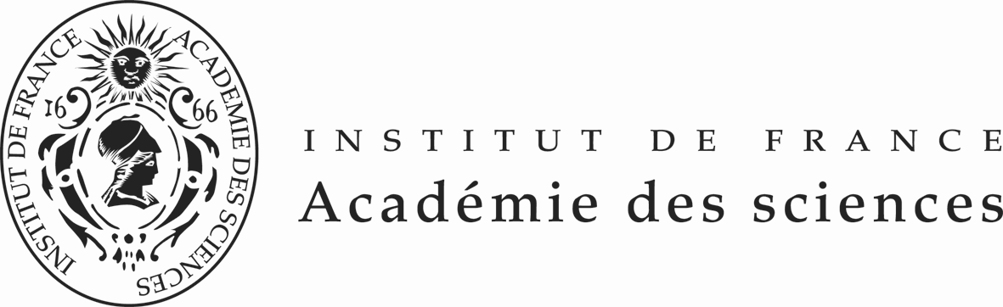

La Fondation Franco-Chinoise
pour la Science et ses Applications (FFCSA)

Post-doctoral Fellowships 2015-2017
Call of offers
(12 months-18 months - 24 months in laboratories selected by the FFSCA)

APPLICATION FORM

Gender: | □ Male □ Female
Name Chinese & English: | Chinese English
Surname Chinese & English: | Chinese English
Age & Birth Date:  and Place of birth: | Day / Month / Year  Place of birth
Address of your Home :
Home  Telephone number:  And mobile phone: | Home  Mobile phone
Name and address of your university/institute:
Office :  Tel Fax number | Tel  Fax
Academic Degree PhD | Type  Field  University  Date obtained ( / / )  Day Month Year
Field of specialization:
Title/Current position:
E-mail address:
English language ability  (5:excellent, …..1:poor) | Reading  Writing  Listening  Speaking
Exam passed in english (name, date and mark)  (for information) | English (TOEFL, TSE, GRE, IELTS ….or others)  TOEFL  or  TSE  or  GRE  or  IELTS  ….  Please send to the FFCSA a copy of the certificate of the english exam you have passed
Previous travels abroad | -Places  -Dates  -Purposes
Current links with french research organizations or academics
If you have been previously awarded from the China Scholarship Council (CSC) fellowship or participated in another CSC research program, please indicate the name of the program and the period of your participation

Name of the Program:
Period of participation:

N° | Please mark with an  | Duration  , location and Supervisor of  the Fellowship | Thematic or subject | Desired Profile
1 | □ | 24 months  Dr Raphaël Scharfmann, Paris | Control of pancreatic development in rodent and human | Medical studies or in biological sciences and motivated
2 | □ | 24 months  Mr Daniel Metzger,  Illkirch | Identification of the molecular  events leading to prostate cancer using mouse models established through conditional somatic mutagenesis. | Good knowledge in molecular biology, physiology , Genetics and pathology  A bioinformatic experience would be an advantage
3 | □ | 24 months  Mr Daniel Metzger,  Illkirch | Pathophysiological role of androgens and glucocorticoids in mouse skeletal muscles. | Good knowledge in molecular biology, physiology , Genetics and pathology  A bioinformatic experience would be an advantage
4 | □ | 24 months  Mme Rouas -Freiss,  Paris | Immunological properties of mesenchymal stem cells and their applications in transplantation and regenerative medicine. | PhD and strong background in immunology
5 | □ | 24 months  Dr Nguyen  Marseille | Toward the Spatial function: identification of protein-protein interaction network
6 | □ | 24 months  Dr Nguyen  Marseille | Deciphering the molecular basis of the complex control of gene expression during sepsis.
7 | □ | 24 months  Mme Swiatowska,  Paris | Surface reactions in lithium ion batteries | Prior experience in electrochemistry and physical chemistry is required. The experience in lithium batteries and surface analytical techniques (XPS, TOF-SIMS) will be highly appreciated
8 | □ | 18 months  Aréva  Saint Etienne | Hot cracking of nickel based alloys | The candidate should have learned metallurgy of steels, if possible welding metallurgy and to a less extent mechanics. The study consits more in experiments at the microscale and the interpretation of the mechanisms of precipitation, diffusion and coalsecence during a thermal cycle.
9 | □ | 24 months  Mme Tavian,  Strasbourg | In vivo and in vitro analysis of the potential ability and fate of ACE+ identified pre-Hematopoietic Stem Cells of the early human embryo | Basic knowledge in Molecular and Cell Biology
10 | □ | 24 months  Mr de la Salle ,  Strasbourg | Analysis of Transfusion-related acute lung injury in mouse models humanized for the expression of HLA class I molecules: role of human antibodies and analysis of cellular responses using in vitro and in vivo systems. | Knowledge in immunology, cell biology, cell culture
11 | □ | 18 months  Prof Mangin  Strasbourg | A causal relationship between tumor cells and platelets: The role of platelet integrins Beta₁ in metastatic dissemination?
12 | □ | 18 months  Mr Jezequel  Lyon | Modeling the dynamic behavior of complex structures
13 | □ | 18 months  Prof Chavel  Bordeaux | The reconstruction of the digital holograms
14 | □ | 18 months  Mr Ordomsky  Lille | Industrial wastewater treatment by continuous ozonation flow-through porous oxides deposited on monolithic reactors
15 | □ | 18 months  Mme Galarenau  Montpellier | Novel nanoreactors with encapsulated metal particles for efficient Fischer-Tropsch synthesis
16 | □ | 18 months  Mr Ph Ricoux, La Defense | Model strong interactions between irregular porous particles immerged in a circulating liquid. | It is expected that the candidate has a good background in fluid dynamics and in multi-phase flows in particular. Knowledge in material sciences and solids characterization are also mandatory. Obviously, a strong interest in experimental validation will be required.
17 | □ | 18 months  Mr Pereira,  Paris | "The profile of the applicant is an  experimentalist, with a good expertise on cold atoms physics".
18 | □ | 18 months  Prof P Reiss, Grenoble | Novel nanostructured materials for thermoelectric. | Chemist or physicist whith experience in the development of thermoelectric generators based on nanoparticles or nanowires.
19 | □ | 12 months  Mr Ph Marcus , Paris | Corrosion at the nanoscale | Prior experience in corrosion science and/or surface science is required. Experience in surface analytical techniques (XPS, ToF-SIMS, STM/AFM) will be highly appreciated

Summary of current research: Subject of past research and achievements made:

- Research Information of the applicant

List of major publications ( maximum 6 )
Authors (all), Year, Title, Journal, Vol, N° , pp.-.

PLEASE SEND TO THE FFCSA THE FIRST PAGE OF YOUR PUBLICATIONS

Applicant’s Signature:

I confirm the information given above is true and correct to the best of my knowledge.
I also understand that incomplete application form or application after the deadline
will result in rejection of the application.

Date Signature of the applicant

Date Signature of the Stamp
President/
Director of University /Institute

